# CS 255 System Design Document Template

This template lays out all the different sections that you need to complete for Project Two. Each section has guidance to prompt your thinking. You will need to continually reference the interview transcript as you work to make sure that you are addressing your client’s needs. There is no required length for the final document. Instead the goal is to complete each section based on what your client’s needs are. Remove this note when you are finished, and replace all bracketed text with the relevant information.

## UML Diagrams

### UML Use Case Diagram

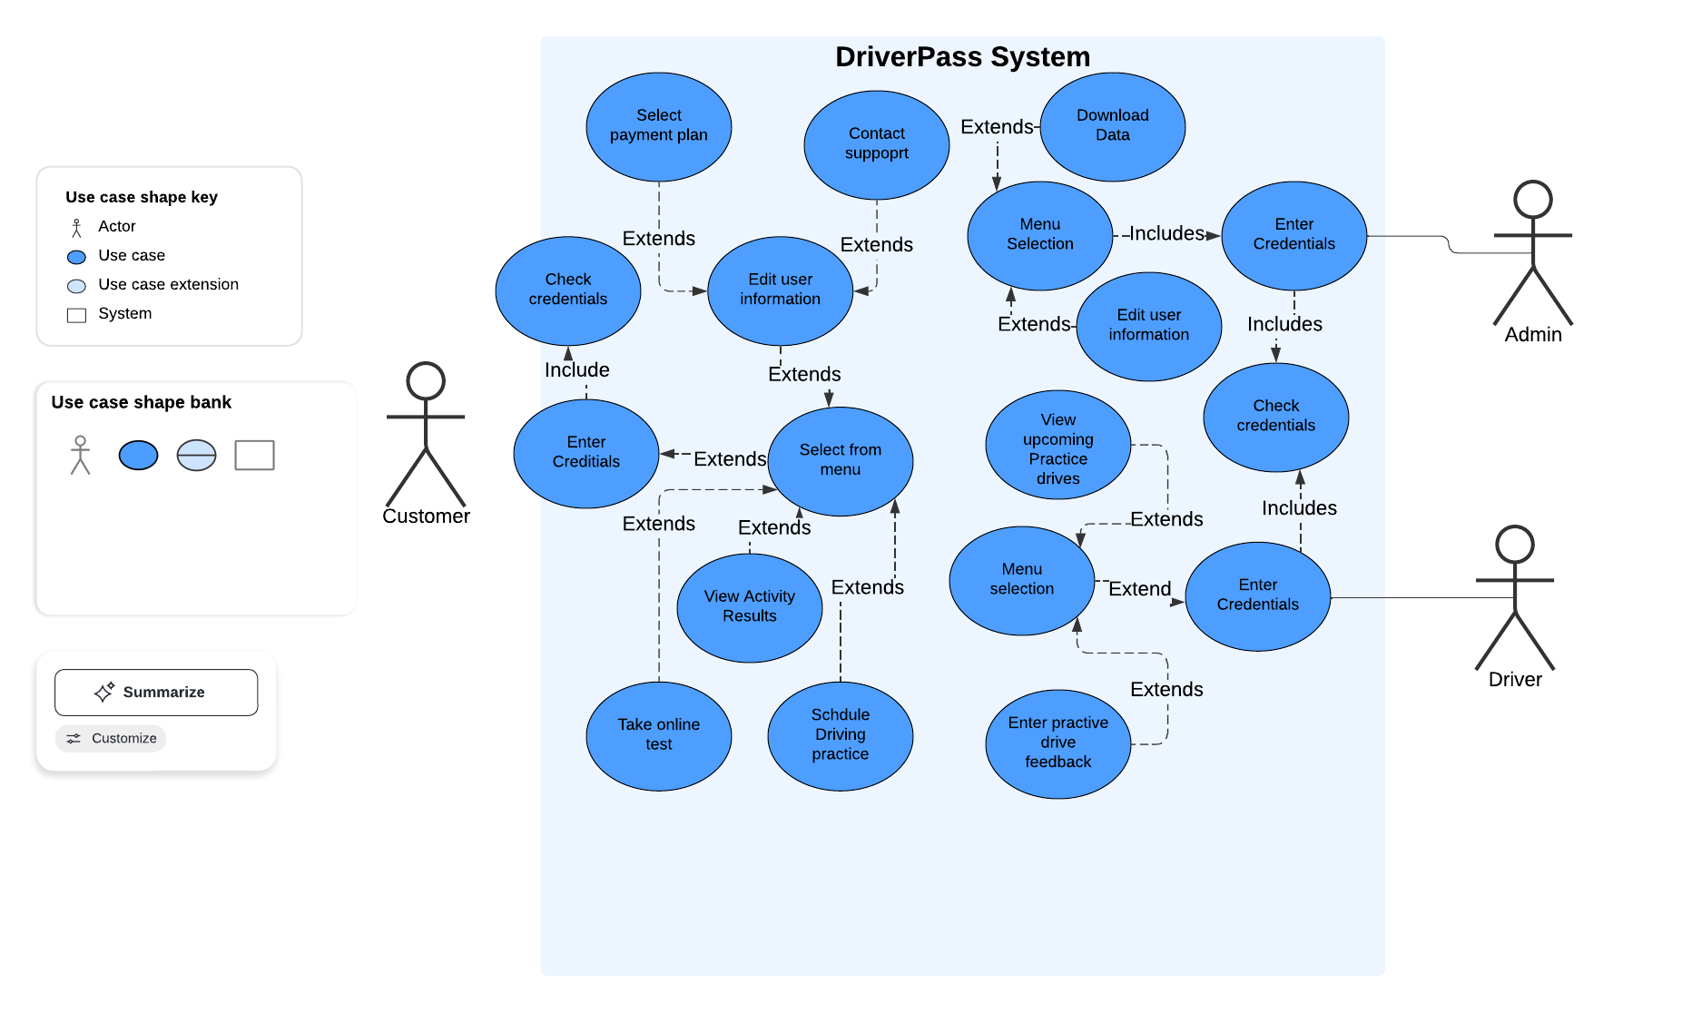

### UML Activity Diagrams

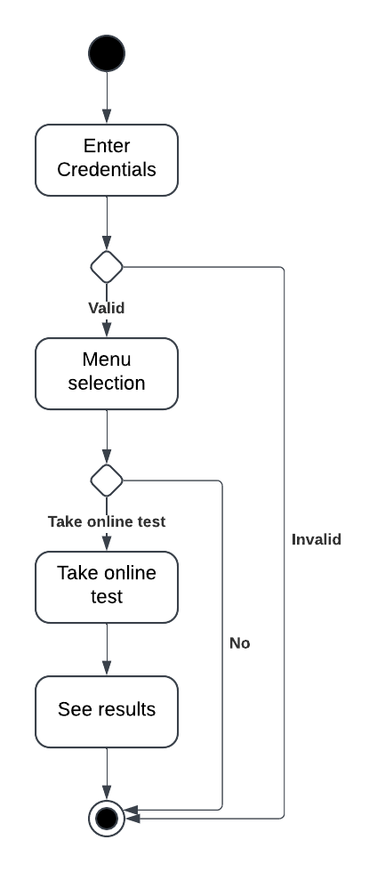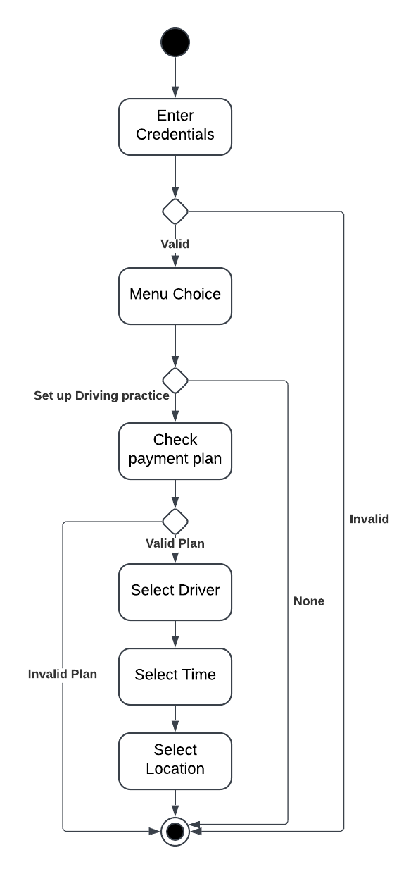

### UML Sequence Diagram

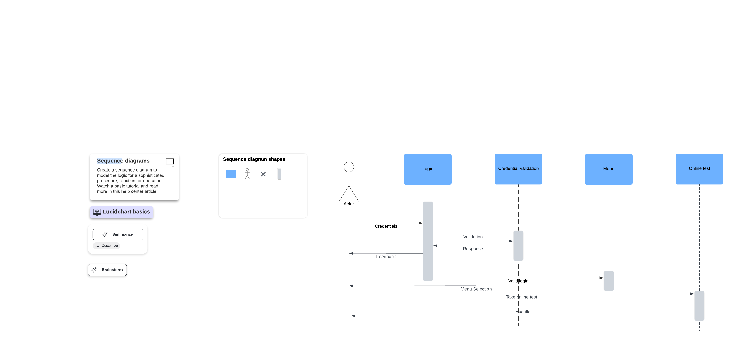

### UML Class Diagram

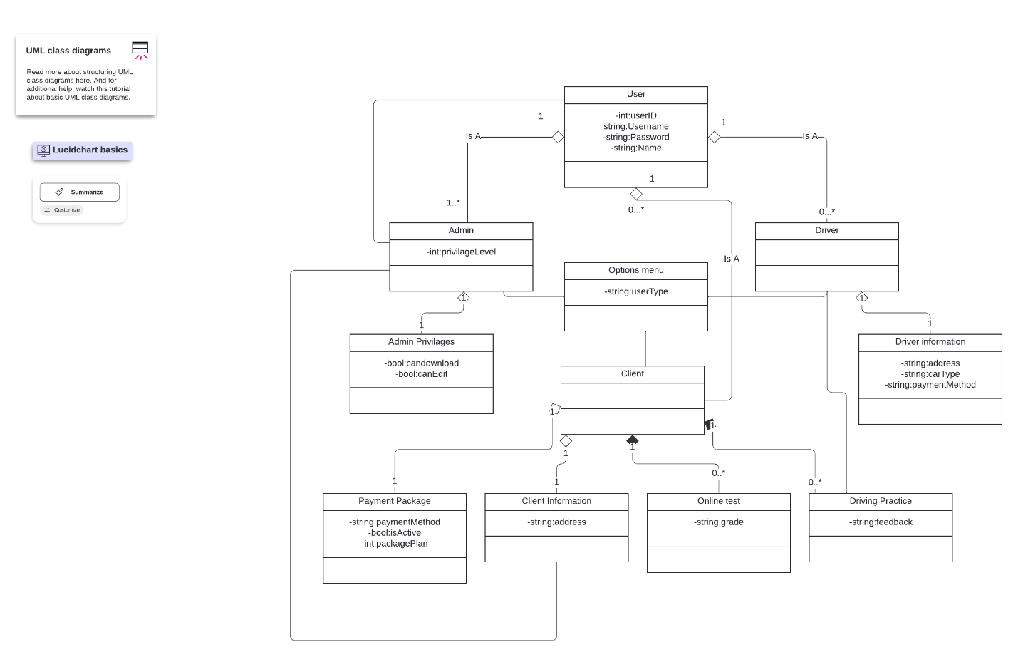

## Technical Requirements

The system can be designed on any type of computer. A Windows with visual studio would probably work best to better integrate the object orientated languages needed for the system. The languages should be C++ for the backend processes, connecting the front end html and python script to the cloud based data and process servers. Cloud processing and data management should be used for this system in the time being because of the limited scale and support team.